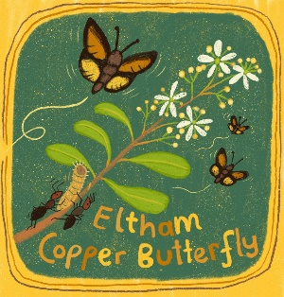

Eltham Copper Butterfly Look-a-likes
By Elaine Bayes, September 2019.
All photographs are Damien Cook or Elaine Bayes unless stated otherwise.
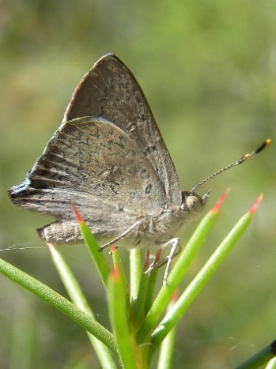  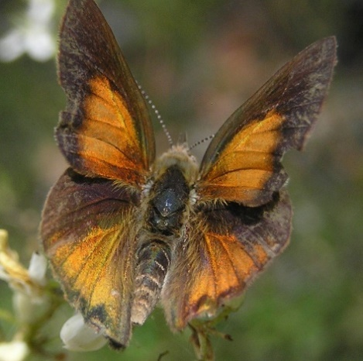  Eltham Copper Butterfly  (Paralucia pyrodiscus lucida).  Wingspan 26mm. From above copper on upper forewing: in central and basal area. In hindwing copper in central and tornal area (towards point).  Larval food plant Sweet Bursaria (Bursaria spinosa).  Attendant ant Notoncus capitatus | Common Ground Butterfly  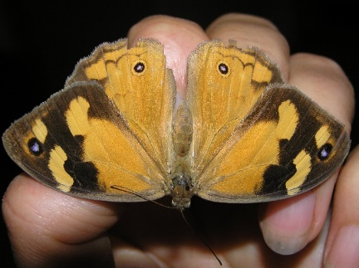  (Heteronympha merope merope)  Female (LHS), male (RHS).  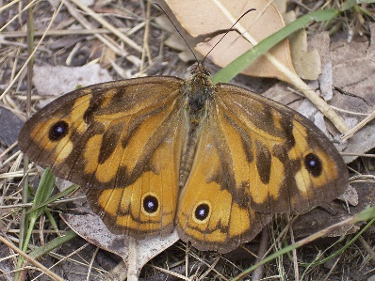  Larval food plant Wingspan: 56-64mm. native grasses
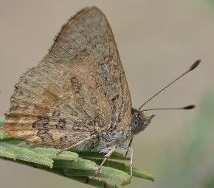  Bright Copper (Paralucia aurifer)  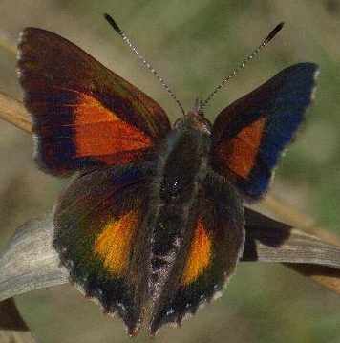  Photo: Russell Best & Reiner Richter from Atlas of Living Australia.  Generally occurs in higher rainfall areas. Macedon is nearerst known population. Wingspan 24mm. From above wings have brown margin with rich copper central area.  Larval food plant: Bursaria spinosa and occassionally Pittosporum in rainforest. Attendant ant: Anonychomyrma sp. | 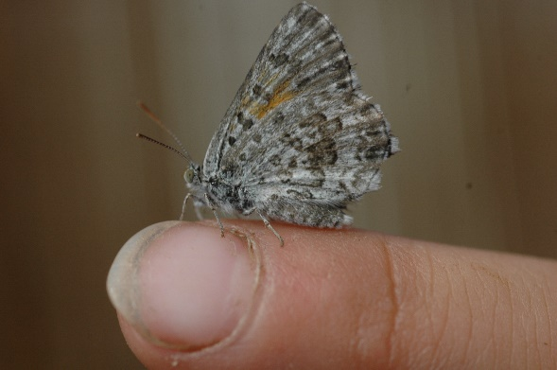  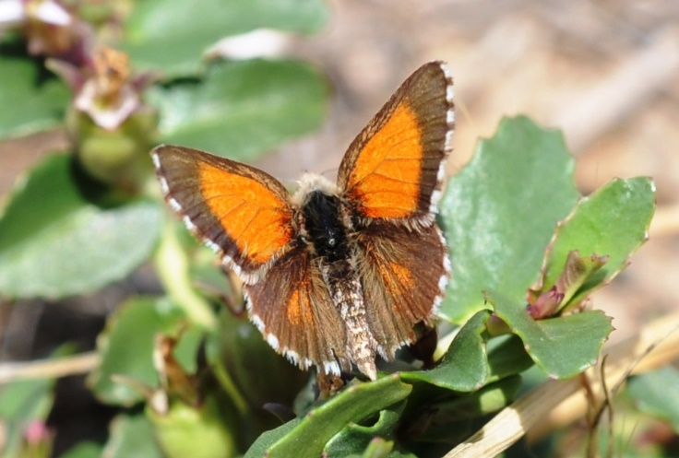  Grassland / Chequered Copper (Lucia limbaria)  Wingspan 24mm. No copper on upperside hind wing; edges of wing with scales fringe checkered brown and white.  Feeds on native Oxalis sp, so more commonly found in Grasslands/Grassy woodlands/urban areas. Attendant ant: Iridomyrmex sp)
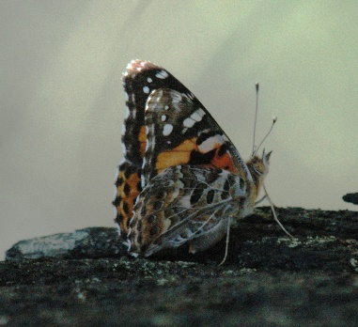  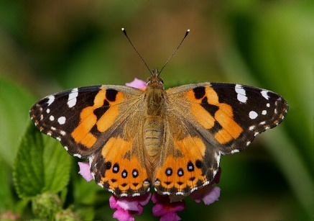  Australian Painted Lady (Vanessa kershawi)  Photo (RHS): David Fischer, http://www.learnaboutbutterflies.com | Yellow Admiral (Vanessa itea)  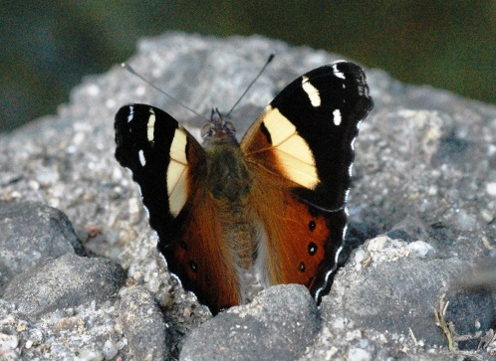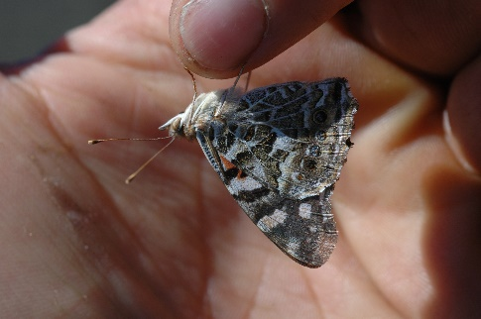  Larval food plant nettles.
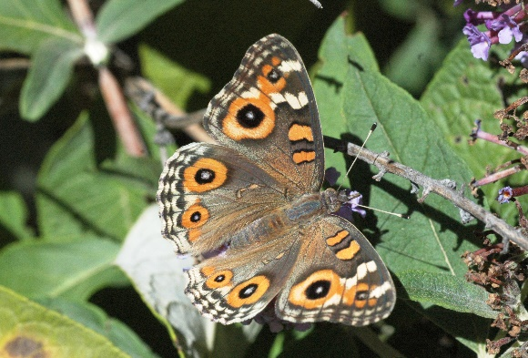  Meadow Argus (Junonia villida calybe) | 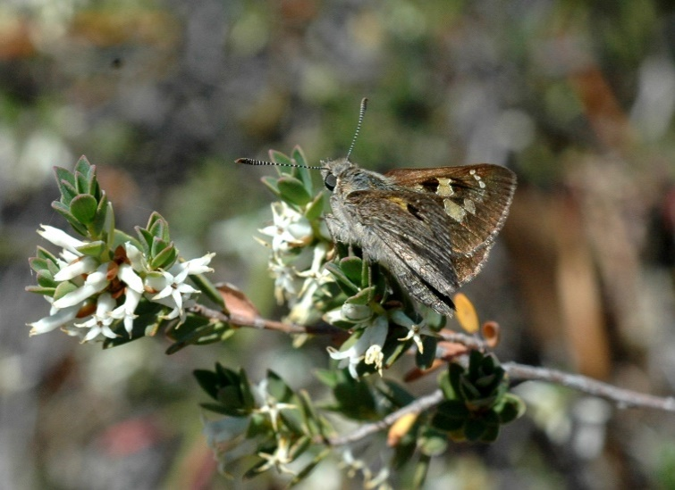  SKIPPER FAMILY ie Heath Ochre  (Trapezites phigalia)  Skippers often fold their wings back.
BLUES FAMILY: There are many small blue butterflies in NC area) which do not have copper on the upper wing.
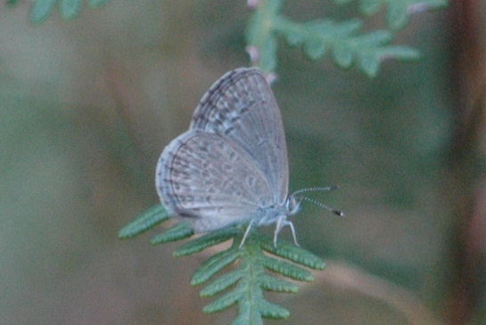  Common Grass Blue (Zizina otis labradus)  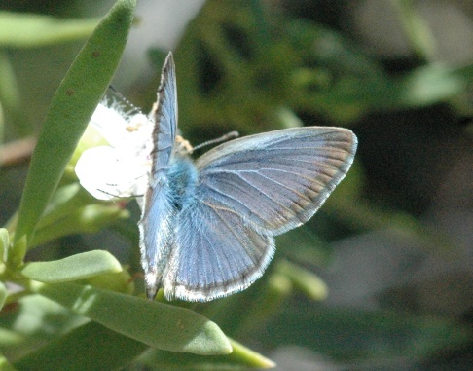  Wingspan 20-23mm. Wings from above lilac-blue. Larval Food plant: legumes. | 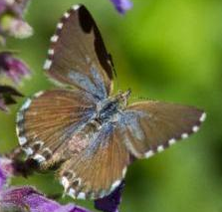  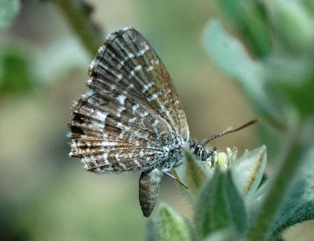  Saltbush Blue (Theclinesthes serpentatus)  Photo (RHS) Graham Possingham, ALA website.  Wingspan: 18mm. The upper wing is purple-brown (no copper). Larval food plant: saltbushes.
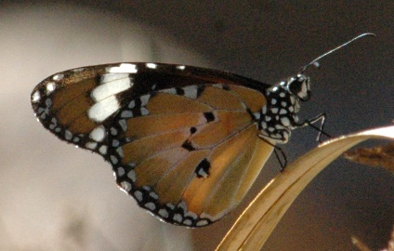  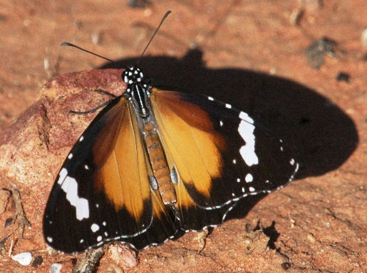  Lesser Wanderer (Danaus petilia) and  Summer migrants, don’t breed in Vic. | 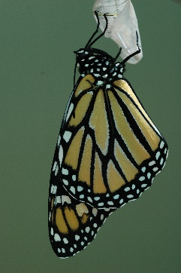  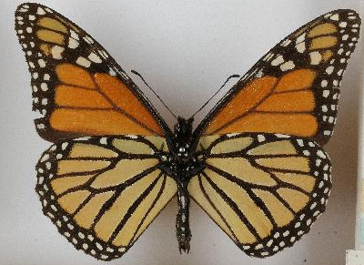  Wanderer or Monarch (Danaus piexippus)  Photo (RHS): from Australian Museum on ALA website.  Summer migrants, don’t breed in Vic.
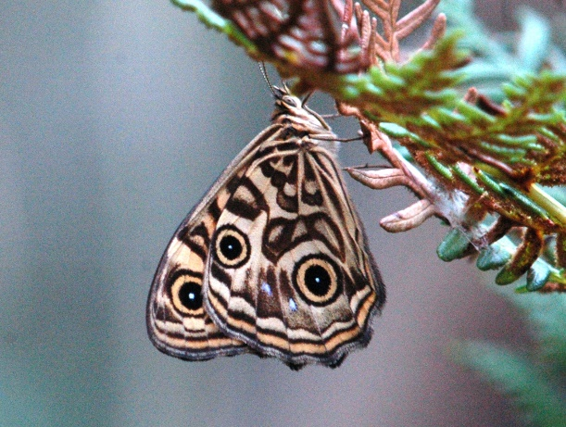  Ringed Zenica (Geitoneura acantha)  Wingspan: 39-44mm. Mostly south in moister areas. Larval food plant Poa sieberiana and Microlaena stipoides. | 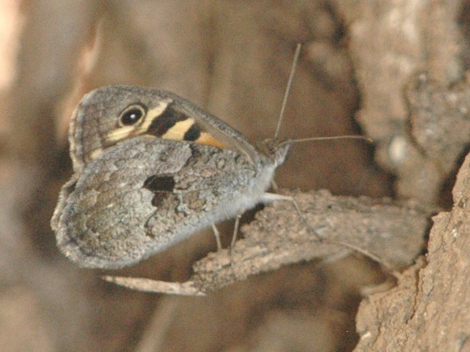  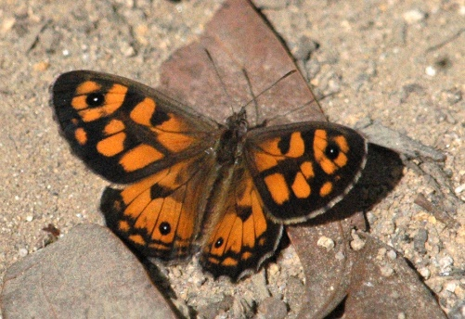  Marbled Zenica (G. klugii)  Wingspan: 40mm. Larval food plant native grasses
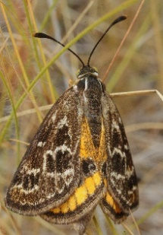
Moths vs Butterflies
- Many moths antenae are feathery (comb-like), butterflies have a long shaft with a ckub at the end.
- Moths fold their wings in at the side. Butterflies hold them straight up over their back.
- Moths fly differently, they generally dart around.

