Eltham Town Centre Design Guidelines

#### PART B - Commercial Core (Precinct 1) Design Guidelines

Final - February 2014

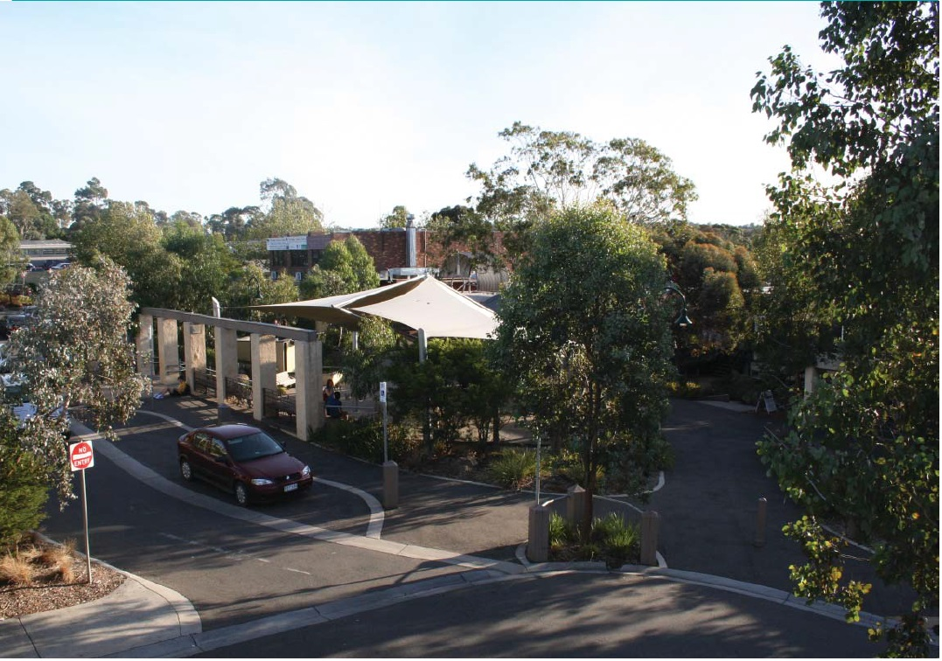

#### PART B – Commercial Core Design Guidelines

##### 1.1 The Commercial Core

The Commercial Core Precinct is generally bounded by Luck Street to the north, Main Road to the west, Dudley Street to the south and residential properties to the east.

These Design Guidelines are intended to be used by anyone who is interested or involved in the planning and development process (landowners, designers, developers, community, Council etc) to better understand how to suitably respond to local planning policies and design controls associated with the Eltham Town Centre.

A Design and Development Overlay (DDO6) applies to land within the Eltham Town Centre, which sets regulations and development expectations to realise the preferred character of the area. Use these design guideline documents to assist in the design phases for all new development within the Eltham Town Centre precincts.

The Eltham Town Centre Design Guidelines have been separated into 2 parts and include the following:

**Part A: The General Design Guidelines (applicable to all land within the Eltham Town Centre Precincts)**

The purpose of the General Eltham Town Centre Design Guidelines is to provide basic design directions for all development formats within the Eltham Town Centre boundary including new commercial, residential and community developments.

**Part B: Precinct Design Guidelines (applicable to land located within the specified precinct boundary)**

The purpose of the Precinct Design Guidelines is to provide specific guidance that supports the preferred character for the each precinct.

Note: All new development must have regard to both documents, PART A & B respectively.

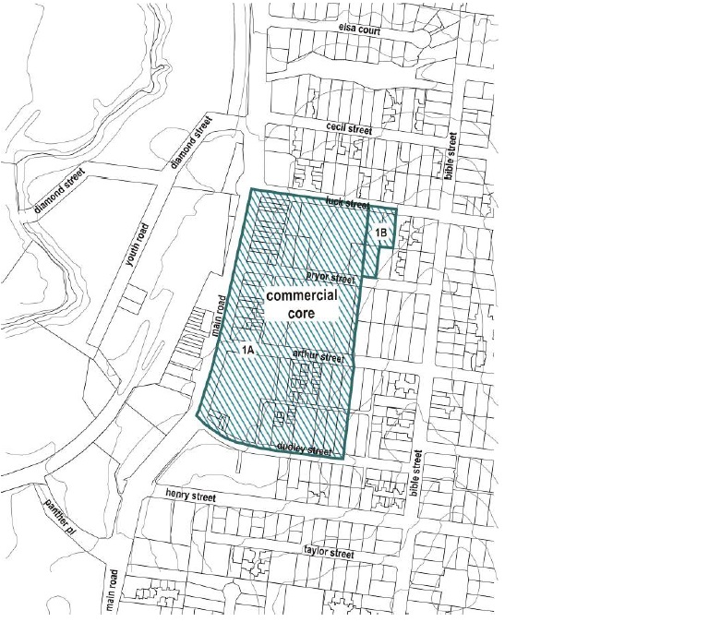

##### 1.2 The Preferred Character

The preferred character for the Commercial Core Precinct includes:

* Development in this area will present a cohesive appearance which relates to the modest scale of the precinct and reflects the Eltham form and character.
* The streets throughout the area will be a focus for pedestrian activity and the buildings will relate positively to the public realm.

##### 1.3 Precinct Design Objectives

* To encourage buildings that relate to the current modest scale of the precinct and emphasise key entrances to the Centre.
* To ensure development provides a transition in scale from the commercial areas to the adjoining low scale residential areas.

#### PART B – Site Design Guidelines

##### SD04: Streetscape Pattern (cont.)

**Design Guidelines and Directions:**

Development fronting Main Road, Luck or Dudley Streets, Arthur and Pryor Streets, Commercial Place and the west side of the Circulatory Road should have a minimum front setback of 5.5 metres from roadside kerbs at ground level.

While buildings of higher intensity are encouraged to occur within the Commercial Core Precinct of the Eltham Town Centre, developments with sensitive interfaces should be designed to limit unreasonable amenity impacts such as overlooking, overshadowing and visual bulk.

Increased side building setbacks are encouraged to occur adjacent to Residential and Public Use Zoned lots and should be sufficient in width to allow for canopy screen planting.

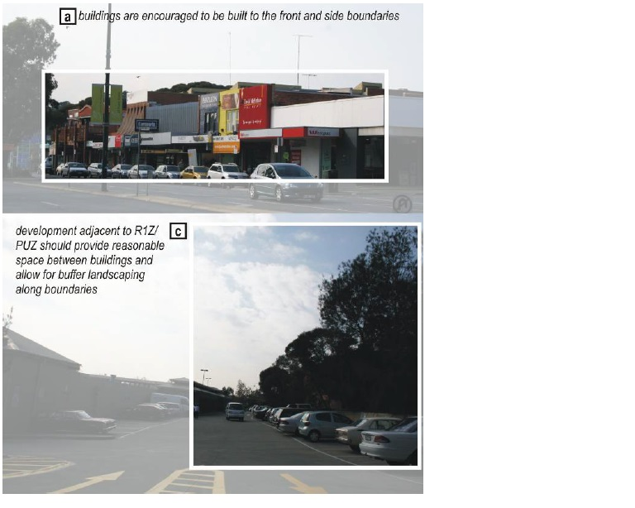

#### PART B – Building Design Guidelines

##### BD01: Building Height and Form (cont)

**Design Guidelines and Directions:**

Overall building height in any part of the precinct must not exceed 5 storeys (17.5 metres).

Building height on sites with frontage to Main Road (Sub precinct 1A) should be limited to a maximum of 5 storeys (17.5 metres) and the 5th storey is to be located in the roof space only. The third storey and above should be recessed a minimum of 3 metres from the first storey wall on any street frontage. The front setback should be a minimum of 5.5 metres from roadside kerbs.

Building height on sites with frontages to Pryor, Arthur or Dudley Streets and to the west side of the Circulatory Road (Sub-Precinct 1A) should also be limited to a maximum of 5 storeys (17.5 metres) and the 5th storey should be located in the roof space only. The third storey and above should be recessed a minimum of 3 metres from the first storey wall on any street frontage. The front setback should be a minimum of 5.5 metres from roadside kerbs.

Building height on sites with frontages to Pryor, Arthur or Dudley Streets (Sub precinct 1A) should also be limited to a maximum of 5 storeys (17.5 metres) and the 5th storey should be located in the roof space only. The buildings should be setback a minimum of 5.5 metres from the roadside kerbs while the third storey and above should be further recessed by a minimum of 3 metres from the first storey wall on any street frontage.

Building height of the development fronting the east part of Luck and Pryor Streets (Sub precinct 1B) should be limited to 4 storeys (14.0m). The 4th storey should be located in the roof space. The third storey should also be recessed a minimum of 3 metres from the first floor frontage. The front setback should be a minimum of 5.5 metres from roadside kerbs.

Ensure new development does not unreasonably interrupt the canopy ridge line and views available to the west.

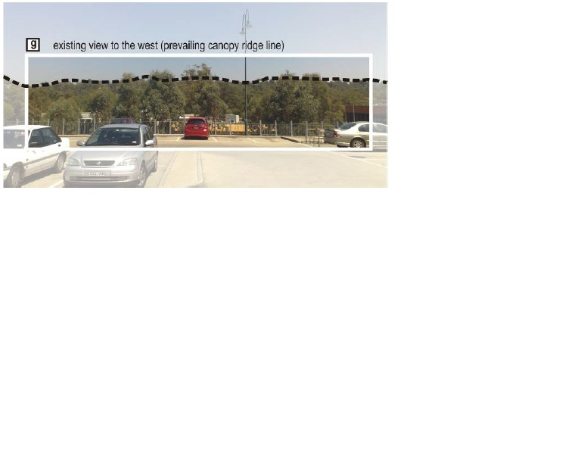

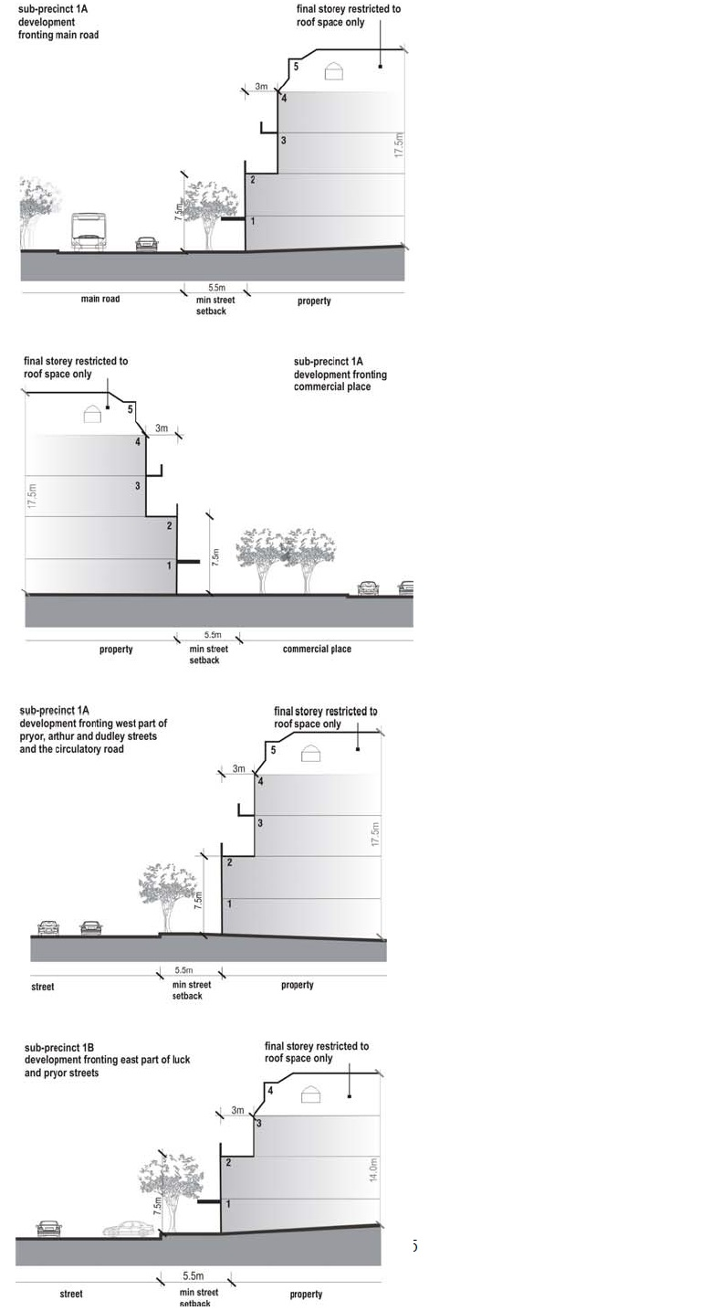

##### BD02: Building Style & Façade Composition (cont)

**Design Guidelines and Directions:**

Buildings on the corners of Dudley Street and Main Road and Luck Street and Main Road should be of high architectural quality with expressed corner building forms to create a sense of entry into this Precinct.

Weather protection for pedestrians should be provided along the Main Road, Pryor Street, Arthur Street and Commercial Place building frontages.

Buildings adjacent to pedestrian pathways should activate the street level through extensive glazing and/ or openings.

Thick and robust buildings elements such as colonnades are common within the Eltham Commercial Core. Incorporate such elements to blend in with existing built form character of the area.

Incorporate clear horizontal / vertical divisions within the façade to relate to the streetscape and subdivision pattern.

Upper levels of new developments should be articulated with building recesses and balcony treatments.

Seek to continue the prevailing streetscape parapet with recessive upper levels.

Use of blank walls and reflective glazing should be avoided.

Upper levels of new developments should be articulated with building recesses and balcony treatments

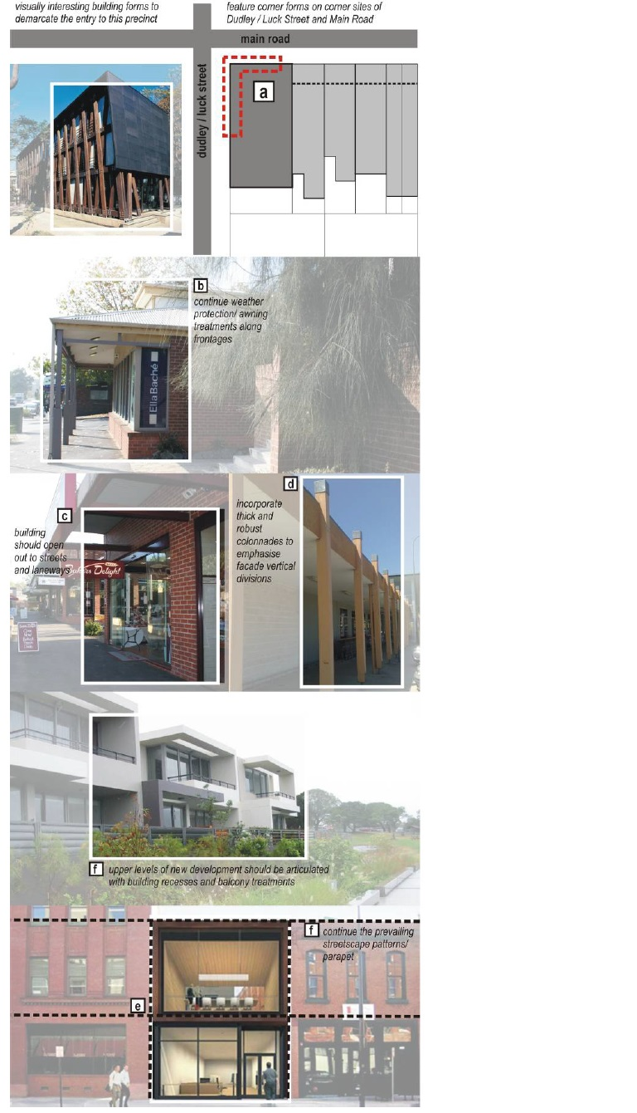

##### PART B – Building Context Guidelines

##### BC01: Access and Parking (cont)

**Design Guidelines and Directions:**

Shade trees should be planted in open air, at grade car parking areas where over 10 car spaces are provided. This planting should be at a ratio of 1 tree per every 10 car spaces.

Ensure new development does not impact on the activity and function of the Eltham Town Square.

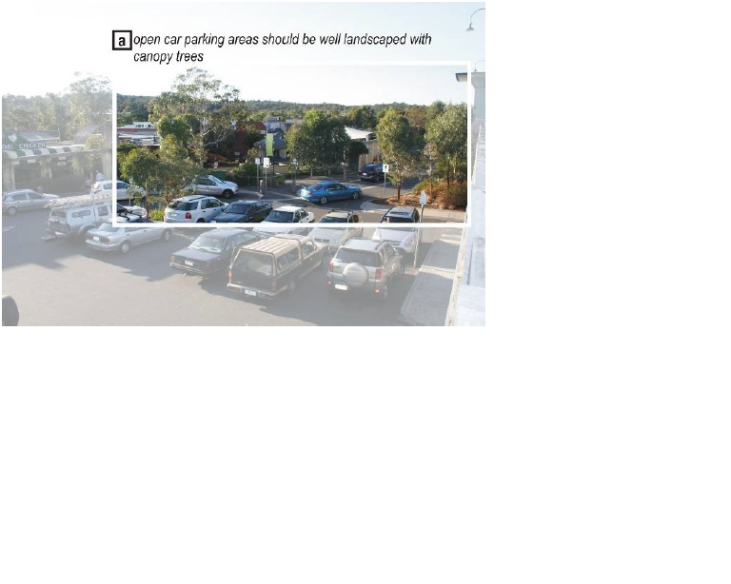

##### BC02: Boundary Treatments - Landscape and Fencing (cont)

**Design Guidelines and Directions:**

As buildings are encouraged to be built to the street boundary, front fencing is strongly discouraged.

##### BC03: Signage and Lighting (cont)

**Design Guidelines and Directions:**

Signage should be less than 10% of the overall building form/ façade.

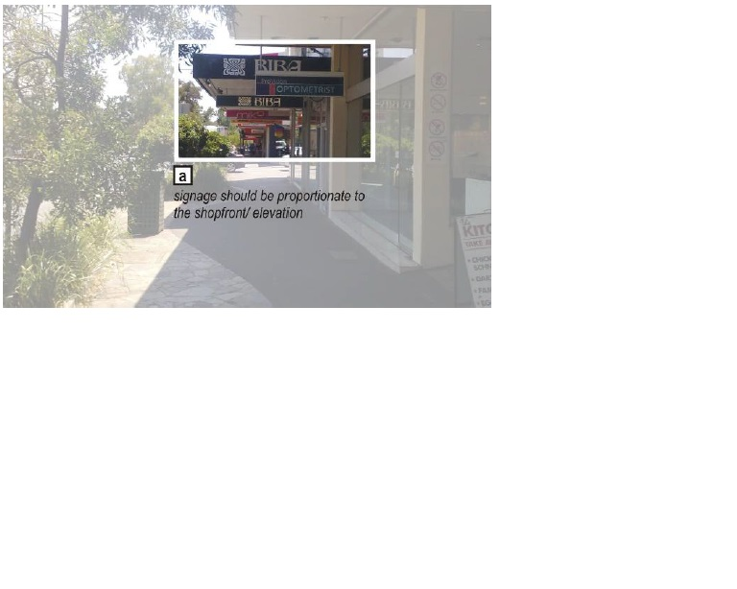

#### PART B – Public Domain Guidelines

##### PD01: Access, Footpaths and Parking (cont)

**Design Guidelines and Directions:**

Accessways proximate to the Eltham Town Square should be designed to foster a low speed environment and reduce pedestrian conflict points. Incorporate traffic calming devices throughout.

Ensure laneway connections to Main Road and the Eltham Town Square are maintained and offer a well lit and safe environment.

Create a new pedestrian link between the Town Square and Main Road by converting one of the retail premises fronting Main Road into an open plaza.

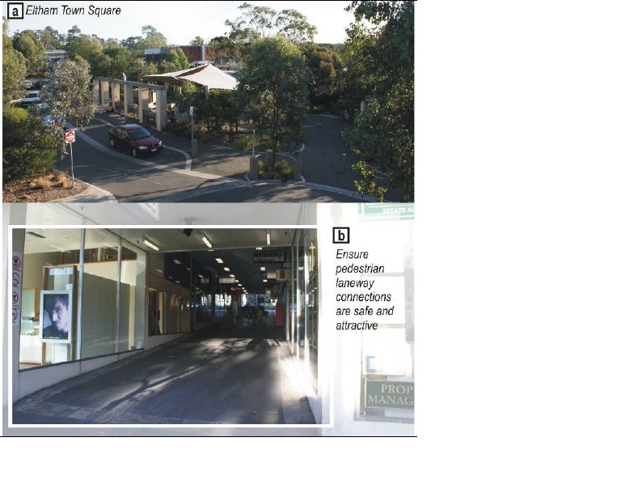

##### PD02: Landscape – Soft and Hard (cont)

**Design Guidelines and Directions:**

Upgrade the existing Town Square. Allow for outdoor café areas / free standing kiosk to be established to promote additional activity within the space.

Plant indigenous tree throughout the precinct.

Shade trees should be planted in open air, at grade parking areas where over 10 car spaces are provided.

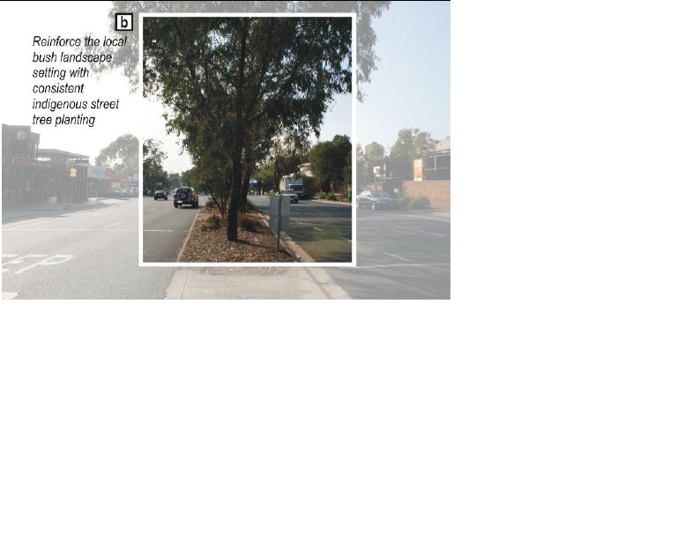

##### PD03: Street Furniture, Lighting and Signage (cont)

**Design Guidelines and Directions:**

Minimise private free standing advertising within streets and pedestrian laneways. Ensure signage (‘A” frame) is no larger than 1m in height, 800mm in width and 500mm in depth.

