Eltham Town Centre Design Guidelines

#### PART B - Residential Interface (Precinct 2) Design Guidelines

Final - February 2014

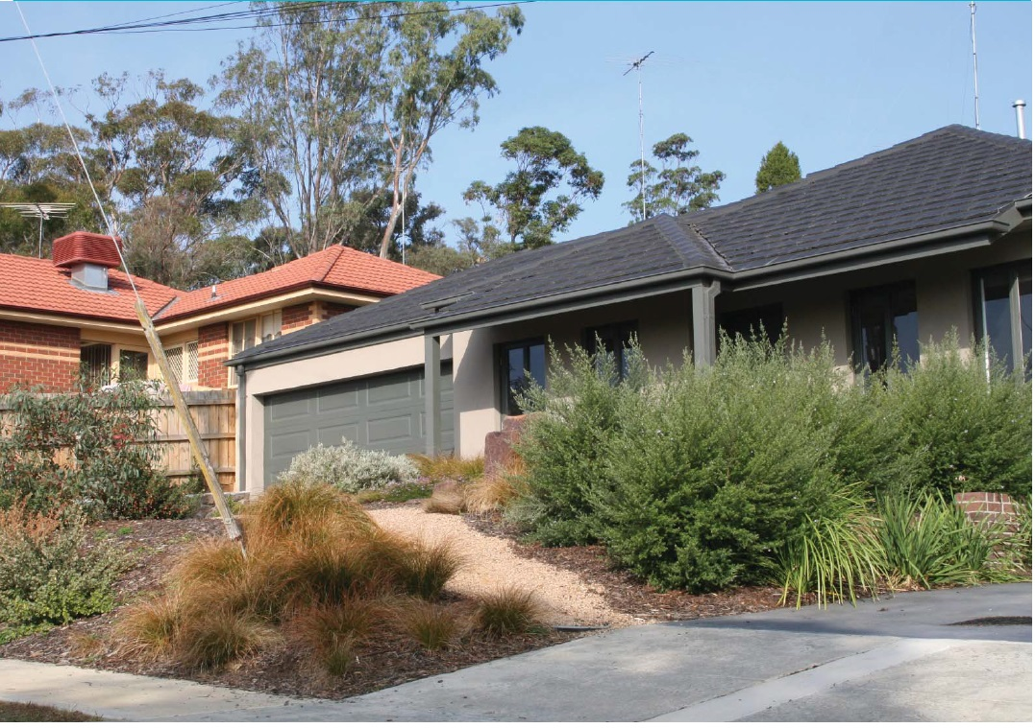

#### PART B – Residential Interface Design Guidelines

##### 1.1 The Residential Interface

The Residential Interface Precinct is generally bounded by Bible Street to the east and residential properties fronting Cecil to the north and Taylor Street to the south.

These Design Guidelines are intended to be used by anyone who is interested or involved in the planning and development process (landowners, designers, developers, community, Council etc) to better understand how to suitably respond to local planning policies and design controls associated with the Eltham Town Centre.

A Design and Development Overlay (DDO6) applies to land within the Eltham Town Centre, which sets regulations and development expectations to realise the preferred character of the area. Use these design guideline documents to assist in the design phases for all new development within the Eltham Town Centre precincts.

The Eltham Town Centre Design Guidelines have been separated into 2 parts and include the following:

**Part A: The General Design Guidelines (applicable to all land within the Eltham Town Centre Precincts)**

The purpose of the General Eltham Town Centre Design Guidelines is to provide basic design directions for all development formats within the Eltham Town Centre boundary including new commercial, residential and community developments.

**Part B: Precinct Design Guidelines (applicable to land located within the specified precinct boundary)**

The purpose of the Precinct Design Guidelines is to provide specific guidance that supports the preferred character for the each precinct.

Note: All new development must have regard to both documents, PART A & B respectively.

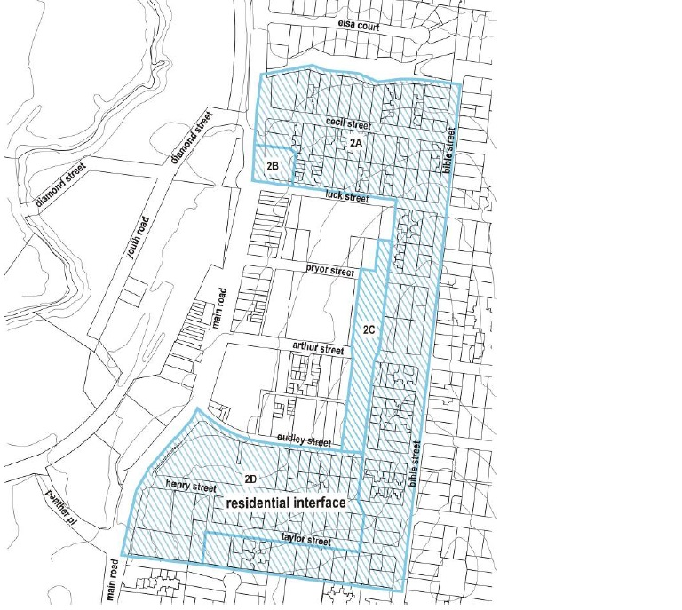

##### 1.2 The Preferred Character

The preferred character for the Residential Interface Precinct includes:

* This area will provide for a transition in built form scale and density between the core commercial areas and the adjoining residential areas.
* This area will provide for an increase in medium density housing and offices while maintaining the spacious and treed appearance of streetscapes.

##### 1.3 Precinct Design Objectives

* To encourage medium density housing and office development that respects the neighbourhood character and any particular design guidelines for the area
* To ensure non-residential development in the Residential Growth Zone maintains a predominantly residential appearance.
* To encourage the consolidation of residential lots for well designed integrated residential developments.

#### PART B – Site Design Guidelines

##### SD04: Streetscape Pattern (cont.)

**Design Guidelines and Directions:**

All buildings within the precinct should provide a minimum front setback to the roadside kerbs of 5.5m.

Residential development located on corner sites must be designed to address both street frontages. Side elevations should be given equal attention on these sites to create ‘multi sided’ buildings.

Residential properties should be consolidated to create higher density residential redevelopment sites.

Consolidated developments should emulate the subdivision pattern of the streetscape. Incorporate articulated facades with building reliefs to correspond with the prevailing pattern.

Buildings with larger footprints should be designed with split levels to respond to the topography.

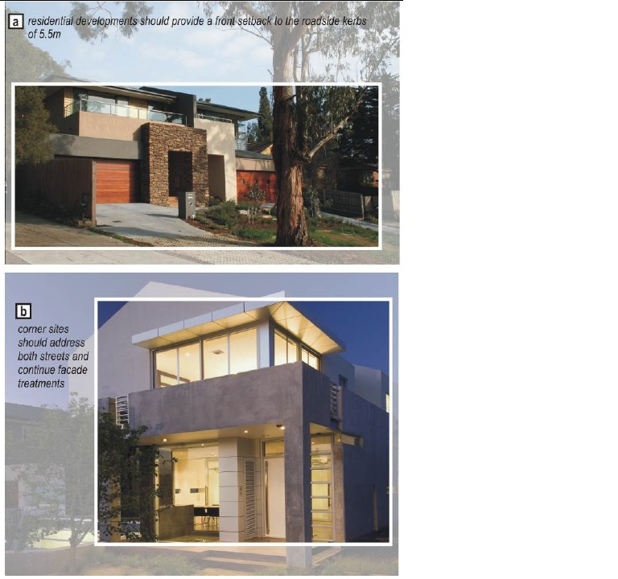

##### SD05: Functionality (cont.)

**Design Guidelines and Directions:**

Private open spaces should be located in useful and meaningful locations rather than left over spaces.

Medium density housing development should be designed to prevent cross viewing between units and neighbouring buildings. Landscaping is the preferred technique to screen views and provide a buffer to adjoining properties.

Development sited alongside boundaries should be massed in a staggered manner to avoid overlooking of adjacent properties and reduce overshadowing impacts.

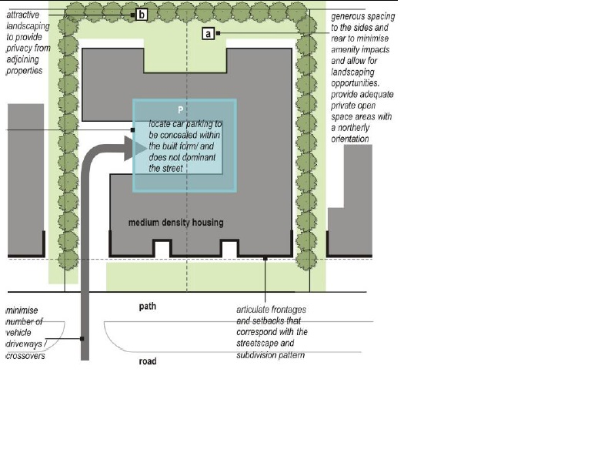

#### PART B – Building Design Guidelines

##### BD01: Building Height and Form (cont)

**Design Guidelines and Directions:**

Overall building height in any part of the precinct must not exceed 4 storeys (14.0 metres).

Building height should be limited to a maximum height of 3 storeys (10.5 metres) within Sub-precinct 2A:

* The third storey should be located in the roof space only.
* The building should be setback a minimum of 5.5m from the road kerbs.

Four storey development is permitted on the north-east corner of Main Road and Luck Street (Sub precinct 2B) and to the land abutting the east side of the Circulatory Road (26 Pryor, 27 Arthur, 28 Arthur and 31 Dudley Streets) and 25 Pryor Street (Sub precinct 2C). The fourth storey should be located in the roof space. The third storey and above should be setback a minimum of a further 3 metres from the first floor frontage. The building should be setback a minimum of 5.5m from the road kerbs. The building must be designed to preserve views from adjoining residential properties to the treed hilltops to the west.

Building height within Sub-precinct 2D to the south of Dudley Street must not exceed 10.5m. The building envelopes should provide a minimum of 5.5m landscaped front setbacks to create opportunities for open space areas and allow for canopy landscaping to be integrated with the total development.

Developments sited along side boundaries should be massed in a staggered manner to avoid overlooking of adjacent properties and reduce overshadowing impacts.

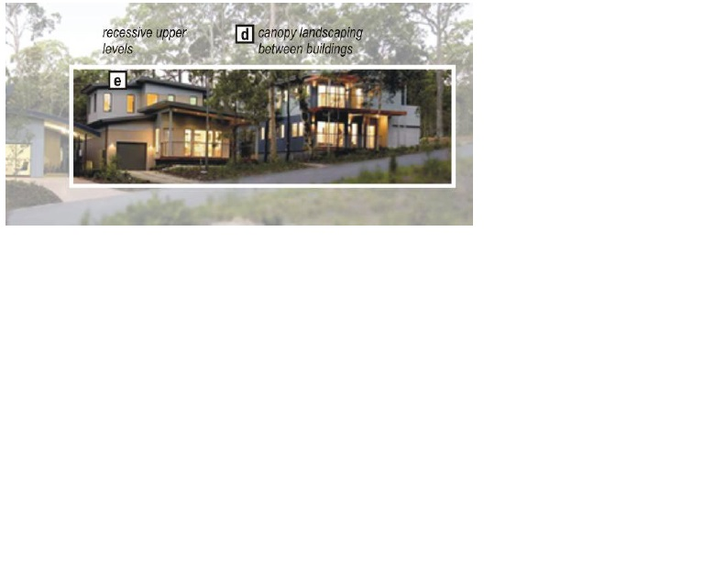

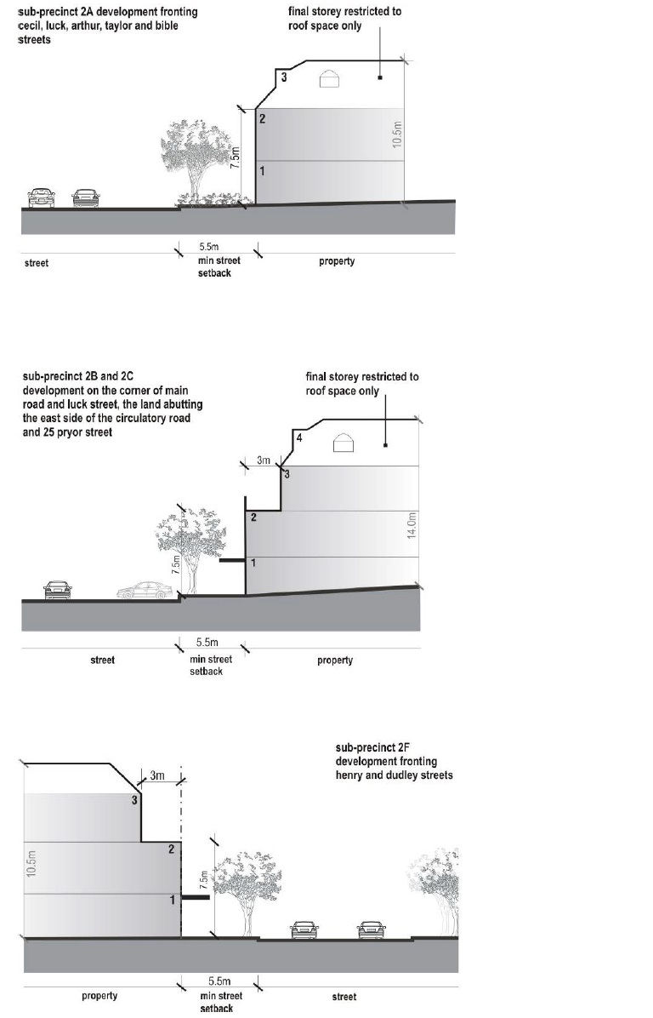

##### BD02: Building Style and Façade Composition (cont)

**Design Guidelines and Directions:**

Main pedestrian entrances should be clearly legible from the street and demarcated with strong architectural and landscape features.

New developments should appear to have a domestic quality and responds to the residential vernacular of the area.

Incorporate a range of materials that are common in the area and select earthy/ muted tones to blend with the landscape.

Incorporate robust elements such as arbours, pergolas and shade structures that are contemporary and simple in style.

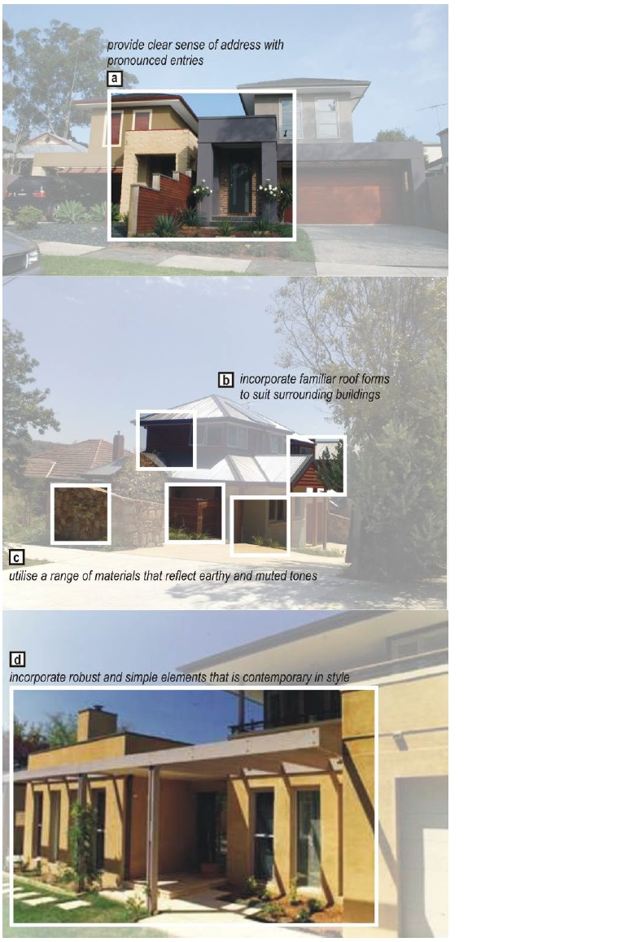

#### PART B – Building Context Guidelines

##### BC01: Access and Parking (cont)

**Design Guidelines and Directions:**

Developments should provide adequate parking spaces to service the requirements of the residential/ users while recognising proximity to the public transport interchange and Activity Centre location.

Garages and carports should be a secondary element to the main façade of the building. Such services should be setback from the main building line except if extensive excavation will be required.

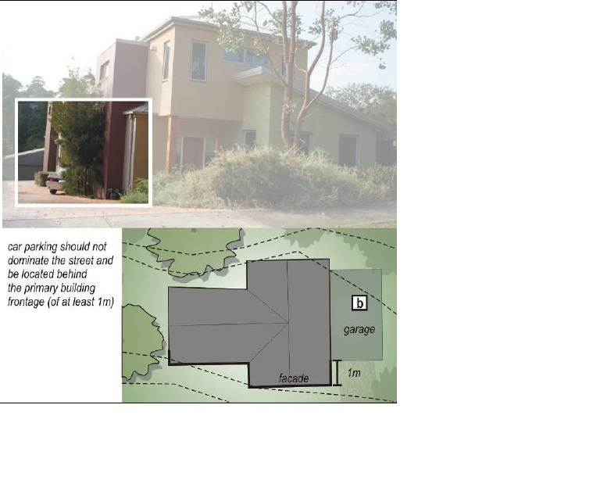

##### BC02: Boundary Treatments - Landscape and Fencing (cont)

**Design Guidelines and Directions:**

It is preferred that front property boundaries are defined by landscape treatments rather than fencing. If front fencing is required, it should be designed to be low in height, visually transparent and avoid dominating the streetscape.

Medium density development should not locate private open spaces and screen fencing to face the street.

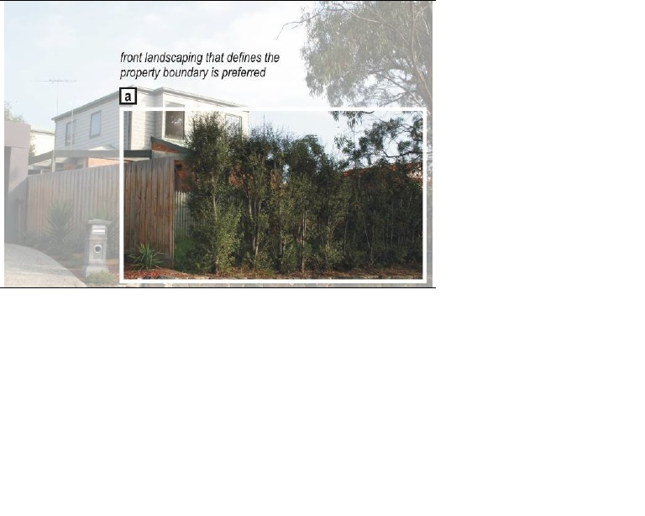

##### BC03: Signage and Lighting (cont)

**Design Guidelines and Directions:**

Signage on non-residential uses should be unobtrusive. It should be subdued in colour, positioned below the eave line and integrated with the surroundings.

The brightness of lighting should be restricted to a level that protects the amenity of the area.

Overhead lights must not be higher than the building height and must be baffled to prevent light spilling into adjoining properties.

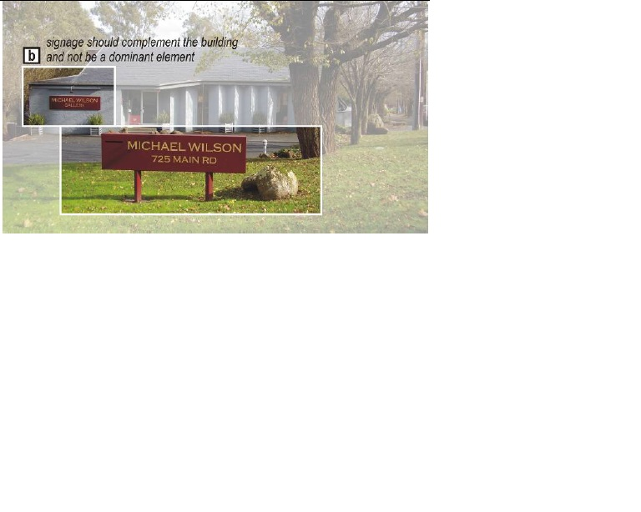

#### PART B – Public Domain Guidelines

##### PD01: Access, Footpaths and Parking (cont)

**Design Guidelines and Directions:**

Extend a special paving treatment and landscaping along Main Road towards Cecil Street to the north and up to Panther Place to the south. This will assist in defining the Eltham Town Centre and enhance a gateway experience.

Upgrade footpaths and ensure bicycle lanes are clearly marked.

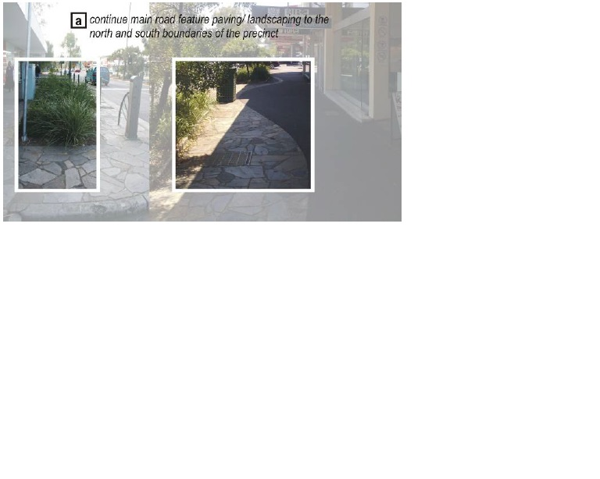

##### PD02: Landscape – Soft and Hard (cont)

**Design Guidelines and Directions:**

Reinforce consistent bush avenues with single theme species along all streets.

Plant indigenous tree where possible.

